### National University of Computer & Emerging Sciences, Karachi Computer Science Department



|  |  |
| --- | --- |
| **Course Code: SE-3003** | **Course : Web Engineering Lab** |

**Spring 2023, Lab Manual – 02**

**LLO 01: Design and Implement a simple web application.**

**Contents:**

* Intro to Web Engineering
* Technologies
* Tools
* HTML Tags basic and advanced
* Intro to CSS

**Introduction to Web Engineering**

Web Engineering is the application of systematic and quantifiable approaches (concepts methods, techniques tools) to cost ‐ effective requirements analysis, design, implementation, testing, operation, and maintenance of **high quality Web applications.**

**Technologies to be studied**

* HTML
* CSS
* JavaScript
* Bootstrap
* JQuery
* PHP
* MySQL [Database]
* Laravel [PHP FRAMEWORK]

**Tools – IDEs**

* Visual Studio Code
* Adobe Dreamweaver
* Visual Studio

**2.1 Basic elements of HTML**

Using HTML, a text file is further marked up with additional text describing how the document should be displayed. To keep the markup separate from the actual content of the HTML file, there is a special, distinguishing HTML syntax that is used. These special components are known as HTML tags. The tags can contain name-value pairs known as attributes, and a piece of content that is enclosed within a tag is referred to as an HTML element.

HTML elements always have opening tags, content in the middle and closing tags. Attributes can provide additional information about the element and are included in the opening tag. Elements can be described in one of two ways:

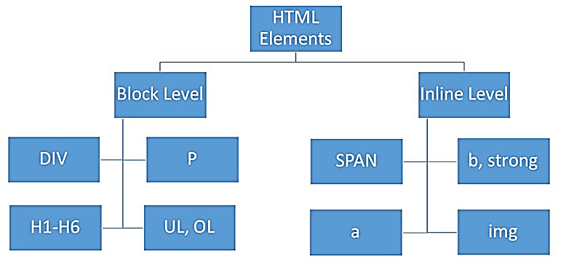

Block-level elements start on a new line in the document and take up their own space. Examples of these elements include headings and paragraph tags.

Inline elements do not start on a new line in the document and only take up necessary space. These elements usually format the contents of block-level elements. Examples of inline elements include hyperlinks and text format tags.

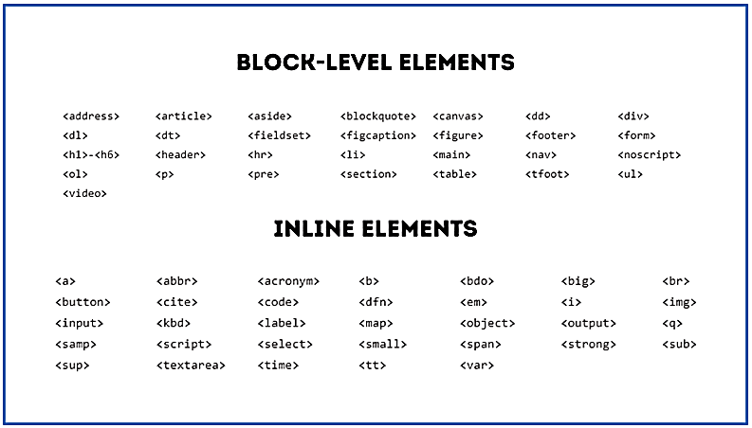

**2.2 Features of HTML5**

HTML5 introduces several elements to increase interactivity, multimedia capabilities and semantic efficiency. Instead of using plugins, multimedia can be placed within the HTML code. These elements include:

Graphics elements:

<canvas>, which creates a blank rectangular space in which web designers can draw using JavaScript.

<svg>, which is a container for scalable vector graphics (SVG).

Semantic elements:

<header>, which creates a header at the top of the page.

<footer>, which creates a footer at the bottom of the page.

<article>, which creates an area for independent content.

<section>, which defines sections and subsections such as chapters, or headers and footers when more than one are necessary.

<nav>, which creates a navigation menu.

Multimedia elements:

<audio>, which describes MP3 files, WAV files and OGG files in HTML.

<video>, which describes MP4, WebM and OGG video types.

Attributes that apply to the <form> element, which creates an area for user input on the web page. These include number, date, calendar and range.

Other main features of HTML5 include:

Elimination of outmoded or redundant attributes.

* Offline editing.
* The ability to drag and drop between HTML5 documents.
* Messaging enhancements.
* Detailed parsing
* MIME and protocol handler registration.
* A common standard for storing data in SQL databases (Web SQL).
* Application program interfaces (API) for complex applications.
* Accommodations for mobile device app development.
* MathML for mathematical and scientific formulas.

While the addition of these features represents an effort to support multimedia embedding, changes to the HTML specification demonstrate the desire of the community for HTML to return to its original purpose of describing the structure of content. Basically, more structural features have been added, while several format-centric features have been deprecated. For the purpose of backward-compatibility, web browsers will continue to support deprecated HTML tags, but eventually HTML will be mainly structure-based.

## HTML Formatting Elements

<b> <b> tag is used to dark the text.

<i> <i> tag is used to Italic the text.

<em> <em> tag is used to write the text in a italic and dark.

<u> <u> tag is used to Underline the Text.

<kbd> <kbd> tag are used to show the Keybord Type Text.

<mark> <mark> tag is used to highlight the text.

<small> <small> tag is used to Small the Text.

<del> <del> tag is used to Strike the Text.

<ins> <ins> tag is used to added the text or modify the text.

<strong> <strong> tag is used to shows the bold or dark text.

<abbr> It will show the content of title attribute as a tooltip.

and typical use of <abbr> is to show the full form of the word.

<code> <code> tag is used to write the text in the machine formate.

<s> <s> tag is used to strike the text.

<samp> <samp> tag is used to write the text in the machine formate.

<sub> <sub> tag is used to write the text in the subscript.<sup> <sup> tag is used to write the text in the superscript.

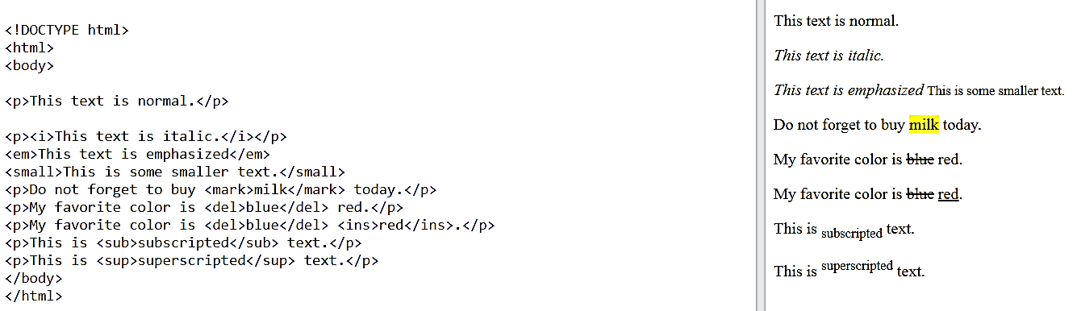

## HTML Quotation and Citation Elements

## 

## Examples:

## <p>Here is a quote from WWF's website:</p> <blockquote cite="http://www.worldwildlife.org/who/index.html"> For 60 years, WWF has worked to help people and nature thrive. As the world's leading conservation organization, WWF works in nearly 100 countries. At every level, we collaborate with people around the world to develop and deliver innovative solutions that protect communities, wildlife, and the places in which they live. </blockquote>

<p>WWF's goal is to: <q>Build a future where people live in harmony with nature.</q></p>

<p>The <abbr title="World Health Organization">WHO</abbr> was founded in 1948.</p>

<p><cite>The Scream</cite> by Edvard Munch. Painted in 1893.</p>

<bdo dir="rtl">This text will be written from right to left</bdo>

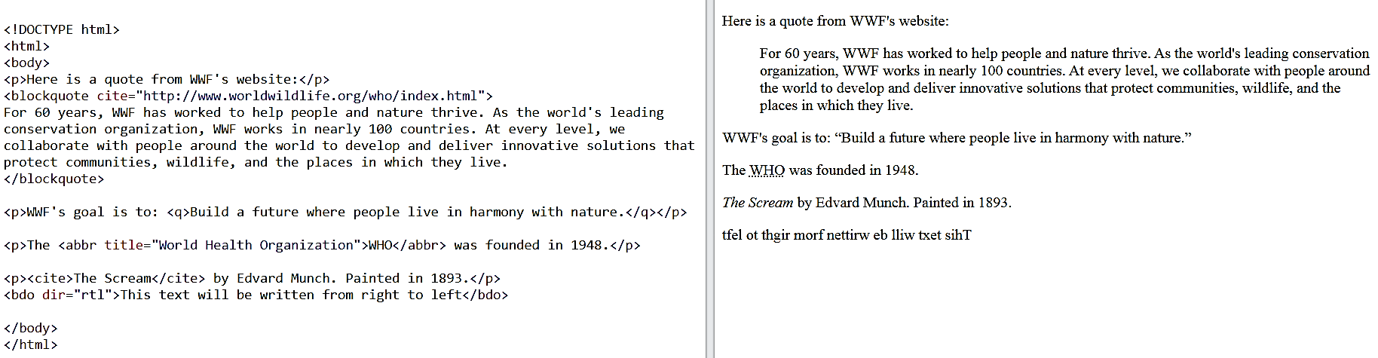

**HTML comments:** are not displayed in the browser, but they can help document your HTML source code.

<!DOCTYPE html>

<html>

<body>

<!-- This is a comment -->

<p>This is a paragraph.</p>

<!-- Comments are not displayed in the browser -->

</body>

</html>

**Links:** Links are found in nearly all web pages. Links allow users to click their way from page to page.

By default, links will appear as follows in all browsers:

* An unvisited link is underlined and blue
* A visited link is underlined and purple
* An active link is underlined and red

The target attribute specifies where to open the linked document. The target attribute can have one of the following values:

* _self - Default. Opens the document in the same window/tab as it was clicked
* _blank - Opens the document in a new window or tab
* _parent - Opens the document in the parent frame
* _top - Opens the document in the full body of the window
* <a href="https://www.google.com/" target="_blank">Visit Google!</a>

**Favicon:**A favicon is a small image displayed next to the page title in the browser tab. You can use any image you like as your favicon. You can also create your own favicon on sites like <https://www.favicon.cc>.

<!DOCTYPE html>  
<html>  
<head>  
  <title>My Page Title</title>  
  <link rel="icon" type="image/x-icon" href="/images/favicon.ico">  
</head>  
<body>  
  
<h1>This is a Heading</h1>  
<p>This is a paragraph.</p>  
  
</body>  
</html>

**Table:**

HTML tables allow web developers to arrange data into rows and columns. Everything between <td> and </td> are the content of the table cell.You can have as many rows as you like in a table; just make sure that the number of cells are the same in each row.

<!DOCTYPE html>

<html>

<style>

table, th, td {

border:1px solid black;

}

</style>

<body>

<h2>TH elements define table headers</h2>

<table style="width:100%">

<tr>

<th>Person 1</th>

<th>Person 2</th>

<th>Person 3</th>

</tr>

<tr>

<td>Emil</td>

<td>Tobias</td>

<td>Linus</td>

</tr>

<tr>

<td>16</td>

<td>14</td>

<td>10</td>

</tr>

</table>

<p>To understand the example better, we have added borders to the table.</p>

</body>

</html>

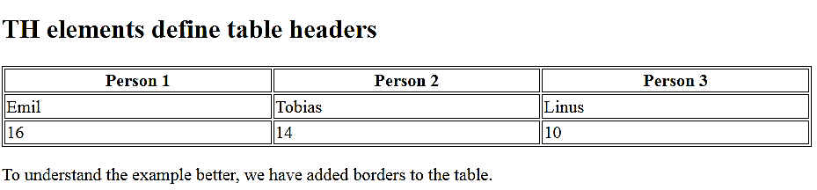

**Row Span | Column Span:**

To make a cell span over multiple columns, use the colspan attribute. Note: The value of the colspan attribute represents the number of columns to span. To make a cell span over multiple rows, use the rowspan attribute: Note: The value of the rowspan attribute represents the number of rows to span.

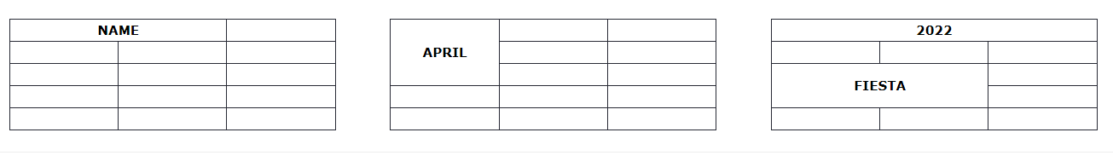

**iFrame:**

An HTML iframe is used to display a web page within a web page. The HTML <iframe> tag specifies an inline frame.An inline frame is used to embed another document within the current HTML document.

**Syntax**

<iframe src="url" title="description"></iframe>

Tip: It is a good practice to always include a title attribute for the <iframe>. This is used by screen readers to read out what the content of the iframe is.

* The HTML <iframe> tag specifies an inline frame
* The src attribute defines the URL of the page to embed
* Always include a title attribute (for screen readers)
* The height and width attributes specify the size of the iframe
* Use border:none; to remove the border around the iframe

**We will use the example direct from YouTube or Google map to understand about it.**

**2.3 ID vs Class in HTML with intro to CSS:**

The id attribute specifies a unique id for an HTML element. The value of the id attribute must be unique within the HTML document. The id attribute is used to point to a specific style declaration in a style sheet. It is also used by JavaScript to access and manipulate the element with the specific id.

The syntax for id is: write a hash character (#), followed by an id name. Then, define the CSS properties within curly braces {}. In the following example we have an <h1> element that points to the id name "myHeader". This <h1> element will be styled according to the #myHeader style definition in the head section:

<!DOCTYPE html>  
<html>  
<head>  
<style>  
#myHeader {  
  background-color: lightblue;  
  color: black;  
  padding: 40px;  
  text-align: center;  
}  
</style>  
</head>  
<body>  
  
<h1 id="myHeader">My Header</h1>  
  
</body>  
</html>

The HTML class attribute is used to specify a class for an HTML element. Multiple HTML elements can share the same class. The class attribute is often used to point to a class name in a style sheet. It can also be used by a JavaScript to access and manipulate elements with the specific class name.

In the following example we have three <div> elements with a class attribute with the value of "city". All of the three <div> elements will be styled equally according to the city style definition in the head section:

<!DOCTYPE html>  
<html>  
<head>  
<style>  
.city {  
  background-color: tomato;  
  color: white;  
  border: 2px solid black;  
  margin: 20px;  
  padding: 20px;  
}  
</style>  
</head>  
<body>  
  
<div class="city">  
  <h2>London</h2>  
  <p>London is the capital of England.</p>  
</div>  
  
<div class="city">  
  <h2>Paris</h2>  
  <p>Paris is the capital of France.</p>  
</div>  
  
<div class="city">  
  <h2>Tokyo</h2>  
  <p>Tokyo is the capital of Japan.</p>  
</div>  
  
</body>  
</html>

**CSS Box Model: [Padding Vs Margin]**

The below image demonstrate us about the differences between them as view;

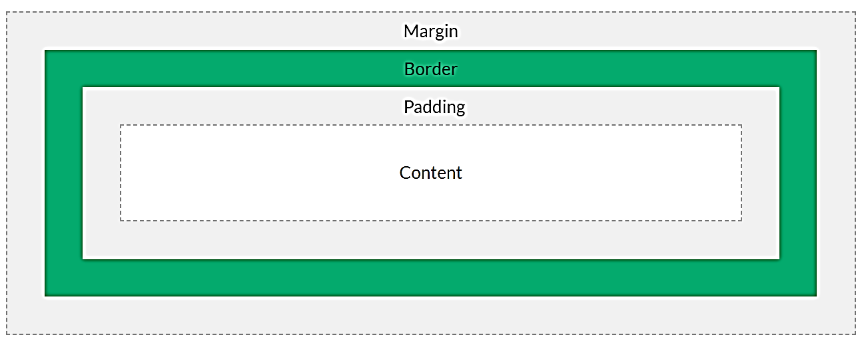

* **Content** - The content of the box, where text and images appear
* **Padding** - Clears an area around the content. The padding is transparent
* **Border** - A border that goes around the padding and content
* **Margin** - Clears an area outside the border. The margin is transparent

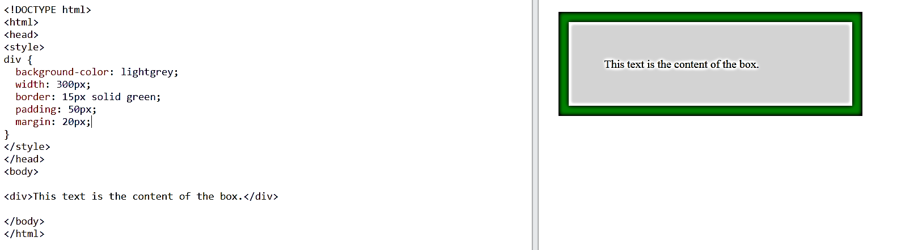

Lab Task

**Task-1**

Create a web page that display the below view;

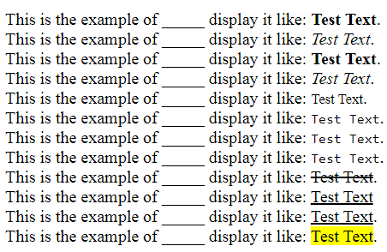

**Task-2**

Create a web page that display the below table;

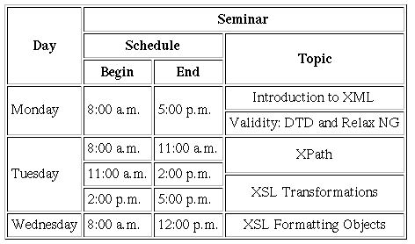

**Task-3**

Create a web page that display the below table;

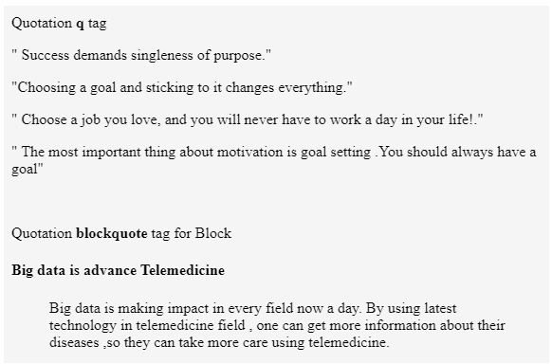

**Task-4**

Create a web page that display the below table;

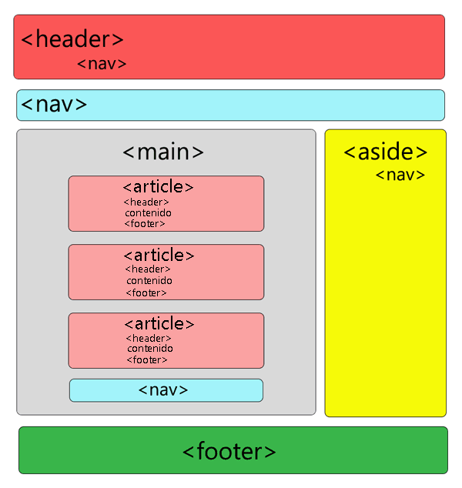

**Task-5**

Create a web page that display the below table;

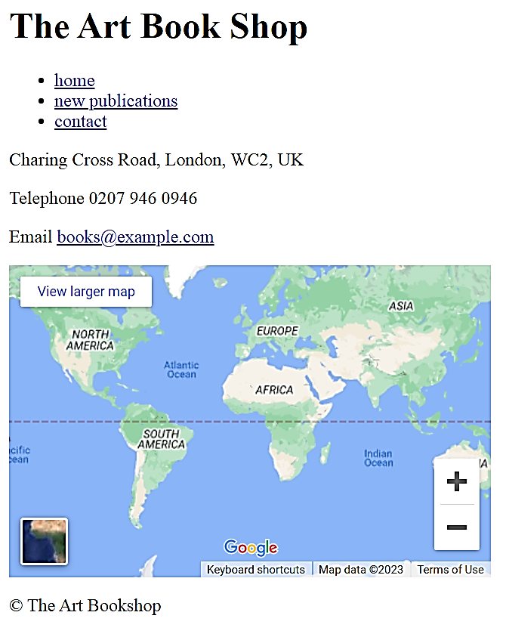

**Task-6**

Create a web page that display the below table;

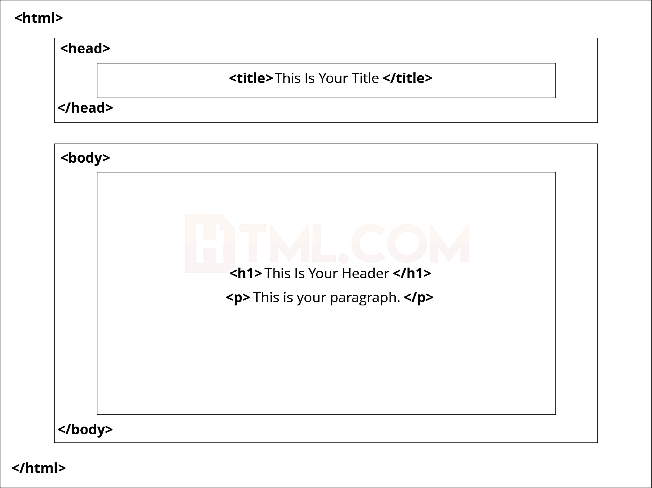

**Task-7**

Create a web page that display the below table;

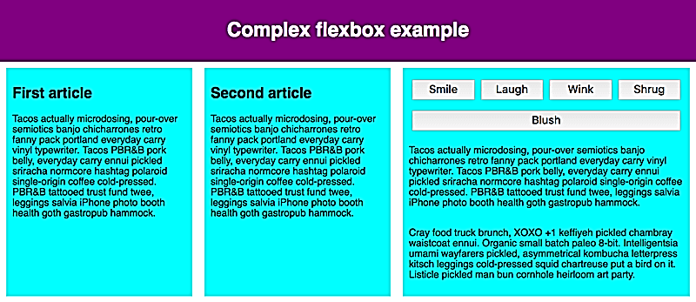

**Task-8**

Create a web page that display the below table;

